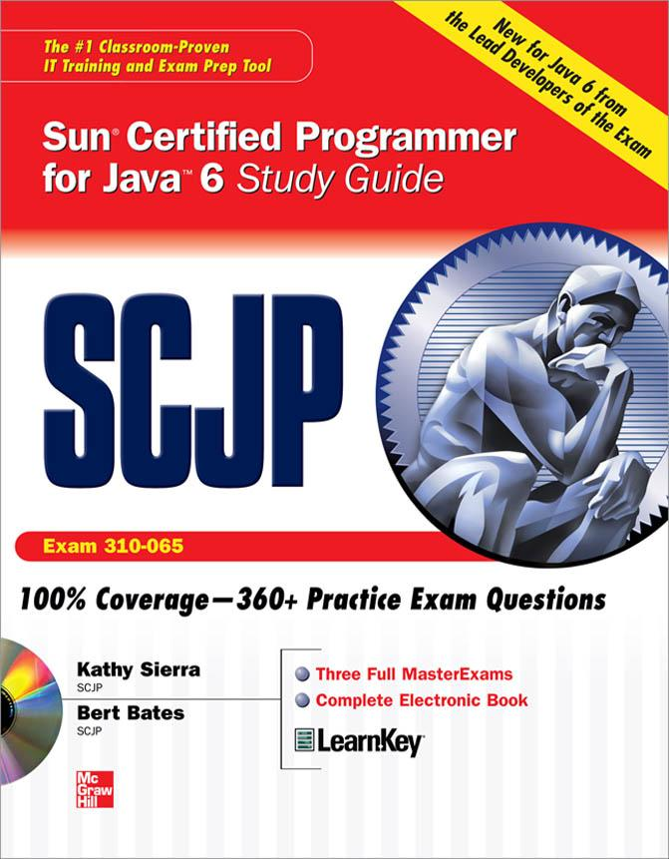

Praise for the Sun Certified Programmer & Developer for Java 2 Study Guide

"Kathy Sierra is one of the few people in the world who can make complicated things seem damn simple. And as if that isn't enough, she can make boring things seem interesting. I always look forward to reading whatever Kathy writes—she's one of my favorite authors."

—Paul Wheaton, Trail Boss JavaRanch.com

"Who better to write a Java study guide than Kathy Sierra, the reigning queen of Java instruction? Kathy Sierra has done it again—here is a study guide that almost guarantees you a certification!"
—James Cubeta, Systems Engineer, SGI

"The thing I appreciate most about Kathy is her quest to make us all remember that we are teaching people and not just lecturing about Java. Her passion and desire for the highest quality education that meets the needs of the individual student is positively unparalleled at SunEd. Undoubtedly there are hundreds of students who have benefited from taking Kathy's classes."

—Victor Peters, founder Next Step Education & Software Sun Certified Java Instructor

"I want to thank Kathy for the EXCELLENT Study Guide. The book is well written, every concept is clearly explained using a real life example, and the book states what you specifically need to know for the exam. The way it's written, you feel that you're in a classroom and someone is actually teaching you the difficult concepts, but not in a dry, formal manner. The questions at the end of the chapters are also REALLY good, and I am sure they will help candidates pass the test. Watch out for this Wickedly Smart book."

—Alfred Raouf, Web Solution Developer

"The Sun Certification exam was certainly no walk in the park, but Kathy's material allowed me to not only pass the exam, but Ace it!"

—Mary Whetsel, Sr. Technology Specialist, Application Strategy and Integration, The St. Paul Companies

"Bert has an uncanny and proven ability to synthesize complexity into simplicity offering a guided tour into learning what's needed for the certification exam."
—Thomas Bender, President, Gold Hill Software Design, Inc.

"With his skill for clearly expressing complex concepts to his training audience, every student can master what Bert has to teach."

—David Ridge, CEO, Ridge Associates

"I found this book to be extremely helpful in passing the exam. It was very well written with just enough light-hearted comments to make you forget that you were studying for a very difficult test. HIGHLY RECOMMENDED!!"

— Nicole Y. McCullough

"I have never enjoyed reading a technical book as much as I did this one…This morning I took the SCJP test and got 98% (60 out of 61) correct. Such success would not have been possible without this book!"
— Yurie Nagorny

"I gave SCJP 1.4 in July 2004 & scored 95% (58/61). Kathy & Bert have an awesome writing style & they literally burnt the core concepts into my head."
— Bhushan P. Madan (Kansas, United States)

"I just took my certification test last week and passed with a score of 95%. Had I not gone through this book, there would have been little chance of doing so well on the test. Thank you Kathy and Bert for a wonderful book!"

— Jon W. Kinsting (Saratoga, California United States)

"Don't hesitate to make this book your primary guide for SCJP 1.4 preparation. The authors have made a marvellous job about delivering the vital facts you need to know for the exam while leaving out tons of otherwise valuable data that fall beyond the scope. Both authors have participated in creating the real questions for the real exam thus providing an invaluable insight to discern the true nature of what you are up to doing. Unlike many other certification guides…this one makes perfect reading. The most boring Sun objectives in the book are nicely interwoven with the gems of refreshingly spicy humor."

— Vad Fogel (Ontario, Canada)
Thank you for evaluating
BCL easyConverter Desktop
This Word document was converted from PDF with an evaluation version of BCL easyConverter Desktop software that only converts the first 3 pages of your PDF.
CTRL+ Click on the link below to purchase
Activate your software for less than $20
http://www.pdfonline.com/easyconverter/

